**Idea3399 Development Kit Based on RK3399**

* Processor: Rockchip RK3399, Dual 64-bit Cortex-A72 + Quad Cortex-A53 @ 1.8GHz
* RAM: 4GB LPDDR4
* Storage: 8GB
* Interfaces: GbE, mDP, 2x Type-C, HDMI, USB2.0 Host, Audio, PWR & Battery, 3x MIPI (LCD, 2x Camera), 3x UARTs, SPI, POE, Micro SD, PCI-E(4G), M.2 slot(SSD), SIM slot, etc.
* Operating system: Android 11, Android7.1.2, Debian 10, Buildroot
* Board size: 135mm x 90mm
* Application: AI and IoT

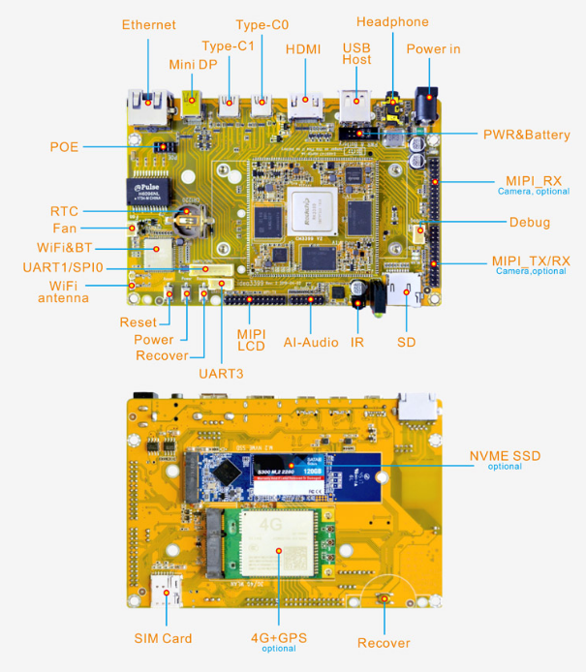

* The board is available with a WiFi/BT module with dual-band 802.11ac/a/b/g/n and Bluetooth 4.1 connectivity.
* Other expansion features include a M.2 slot, 2x MIPI Cameras, MIC Array, 8-pin PoE connector, IR in, etc.
* Idea3399 adopts ALC5651 dual I2S interface audio codec that supports analog/digital input. The 2x USB3.0 Type C can be converted to HDMI/USB3.0/USB2.0. In addition, Type C0 also can be used for debugging.

**Specifications:**

|  |  |
| --- | --- |
| **CPU** | · Rockchip RK3399. Big.Little architecture: Dual Cortex-A72 + Quad Cortex-A53, 64-bit CPU · 28nm HKMG process · 1MB unified L2 Cache for Big cluster, 512KB unified L2 Cache for Little cluster |
| **GPU** | · ARM Mali-T860MP4 GPU, support OpenGL ES1.1/2.0/3.0/3.1/3.2, OpenCL1.2, DirectX11.1 etc. · Supports AFBC (ARM Frame Buffer Compression) |
| **Memory** | 4GB LPDDR4 |
| **Storage** | 8GB eMMC |
| **Power** | DC 5V/3A or 3.6V~12.8V Li-Battery |
| **Ethernet** | 1000M High performance Ethernet (RTL8211E), RJ45 interface |
| **MINI DP** | 1x mini Display Port |
| **USB** | 1x USB2.0 Host, 2x USB3.0 Type C |
| **HDMI** | HDMI 1.4 and 2.0, support 4K, 1080P, 720P, 480P resolution |
| **Audio** | Realtek ALC5651 Audio CODEC. 3.5mm jack for headphone; 14-pin header for MIC Array. |
| **PWR&Battery** | 2x5pin connector. 3.7V Li-Battery |
| **MIPI** | 3x 26-pin headers. MIPI RX for camera1, 13 Megapixels; MIPI RX/TX for camera2, 13 Megapixels; MIPI TX for MIPI LCD. |
| **Micro SD** | 1x Micro SD Card slot |
| **IR** | Support IR in |
| **UART** | 4-wire UART1(Multiplexed signal with Ethernet), 1x 8pin connector (J13); 3-wire UART2, 1x 3pin connector. For debug; 4-wire UART3(Multiplexed signal with Ethernet), 1x 4pin connector |
| **SPI** | 1x 8pin connector (J13) |
| **Buttons** | 3x Buttons for Recover, Power and Reset |
| **RTC** | 3V battery, CR1220 |
| **POE** | 2x4pin connector |
| **4G** | 52pins MINI PCI-E Socket. Support 4G module |
| **SSD (optional)** | NVME SSD PCI.E X2 |
| **Camera (optional)** | 13 Megapixels, OV13850 model |
| **WiFi&BT** | Wireless-2.4GHz/5GHz 802.11 a/b/g/n/ac. Bluetooth 4.1 |
| **Dimension** | 135mm x 90mm |

**Block Diagram**

